

# Monitoring Incident States for Effective Management

Submitted by :

1.Logeshwaran I (au723721205025)

2.Senthilkumar R (au723721205040)

3.Kiran Ram N (au723721205024)

4. Paranjothi V (au723721205304)

# Monitoring Incident States for Effective Management

This project, titled *Monitoring Incident States for Effective Management*, is designed to address a critical challenge in modern operational environments: ensuring efficient incident tracking and resolution. The initiative aims to enhance organizational capability by implementing a robust system for monitoring the lifecycle of incidents, thereby promoting transparency, accountability, and streamlined management processes. By leveraging advanced technologies, innovative platforms, and strategic methodologies, this project seeks to deliver a comprehensive and scalable solution that addresses both immediate and long-term needs.

Incidents, whether technical disruptions, safety hazards, or operational anomalies, can have far-reaching consequences if not managed effectively. The absence of a reliable system to track these incidents often results in delays, miscommunication, and inefficiencies, which can impact an organization’s operational efficiency and customer satisfaction. This project aims to address these issues by introducing a monitoring framework that captures, categorizes, and tracks incidents in real time, ensuring all stakeholders are aligned and informed at every stage of the resolution process.

The core objective of the project is to leverage cutting-edge technologies, such as cloud-based platforms, data analytics tools, and automation techniques, to provide a seamless and intuitive system for incident monitoring. The framework will be designed to integrate with existing infrastructure, allowing for real-time data collection and analysis. Automated alerts and notifications will ensure that responsible teams are immediately informed of incident status changes, enabling faster response times and minimizing downtime.

One of the primary benefits of this initiative is the enhancement of operational efficiency. By automating routine tasks, such as status updates and reporting, the system will free up valuable human resources, allowing them to focus on strategic activities. Furthermore, it will provide decision-makers with access to detailed analytics and insights, helping them identify patterns, prioritize issues, and allocate resources more effectively. The project also aims to improve data accuracy by eliminating manual entry errors and ensuring all records are updated in a timely and consistent manner.

**2. Objectives:**

# Business Goals

1. **Enhance Operational Efficiency:** Streamline the process of incident management to reduce response and resolution times, minimize operational downtime, and ensure uninterrupted business continuity.
2. **Promote Transparency and Accountability:** Implement a system that provides visibility into incident states for all stakeholders, ensuring clear ownership and accountability at every stage of the incident lifecycle.
3. **Improve Decision-Making: Provide** leadership with actionable insights through realtime data, enabling data-driven decisions to optimize resource allocation and prioritize critical incidents.
4. **Increase Stakeholder Satisfaction**: Ensure that internal teams and external clients experience a smoother and more predictable incident resolution process, resulting in improved trust and satisfaction.
5. **Support Compliance and Reporting**: Align incident management processes with regulatory standards and organizational policies, ensuring consistent documentation and audit readiness. Specific Outcomes
6. **Comprehensive Incident Monitoring Framework:** Develop and deploy a centralized system capable of capturing, tracking, and managing incidents from initiation to closure, with real-time updates and alerts.
7. **Automated Notifications and Reporting**: Introduce automated workflows to send timely alerts to relevant stakeholders, reducing response delays and ensuring seamless communication across teams.
8. **Dashboard for Real-Time Visibility**: Deliver an interactive dashboard that provides a consolidated view of all incidents, including their status, priority level, resolution timelines, and assigned personnel.
9. **Reduction in Incident Resolution Time:** Achieve measurable improvements in mean time to resolution (MTTR) by streamlining processes and eliminating inefficiencies in incident tracking and escalation.
10. **Data Analytics and Insights**: Implement analytics tools to identify trends, recurring issues, and root causes, enabling proactive measures to prevent future incidents.
11. **Integration with Existing Systems**: Ensure seamless integration with existing infrastructure and tools (e.g., ticketing systems, communication platforms) for cohesive and efficient workflows.
12. **Scalable and Adaptive Design**: Develop a solution that can scale with organizational growth and adapt to changing business needs, ensuring long-term relevance and usability.

## 3. Key Features and Concepts Utilized

**Key Features**

1. **Real-Time Incident Tracking**:
   * A system to capture and monitor incidents from initiation to resolution. o Real-time updates ensure that all stakeholders are informed of the latest status changes.
2. **Centralized Dashboard**:
   * A user-friendly dashboard consolidates all incident-related data into a single view. o Visualizations, such as graphs and heatmaps, provide insights into trends and priorities.
3. **Automated Notifications and Alerts**:
   * Instant alerts via email, SMS, or internal communication tools ensure rapid stakeholder engagement. o Notifications are triggered by predefined conditions, such as status changes, approaching deadlines, or escalations.
4. **Incident Categorization and Prioritization**:
   * The system categorizes incidents based on type, severity, and impact.
   * Priority levels are assigned automatically to guide response efforts effectively.
5. **Workflow Automation**:
   * Automation of routine tasks, including ticket creation, status updates, and follow-ups.
   * Predefined workflows ensure consistency and reduce human intervention.

**Concepts Utilized**

1. **Incident Lifecycle Management**:
   * Framework based on identifying, recording, classifying, investigating, resolving, and closing incidents systematically.
2. **Data-Driven Decision-Making**:
   * Leveraging data analytics to prioritize incidents, allocate resources, and predict potential risks.
3. **Automation and AI**:
   * Utilizing automation for repetitive tasks and AI-driven algorithms for predictive analysis and intelligent escalation.
4. **User-Centered Design (UCD)**:
   * Developing interfaces and workflows tailored to the needs and preferences of end-users, ensuring ease of adoption.
5. **ITIL (Information Technology Infrastructure Library) Framework**:
   * Incorporating ITIL principles to align incident management with best practices for IT service management.

**4. Detailed Steps to Solution Design :**

**Step1 :** first we need to know that project title**.**

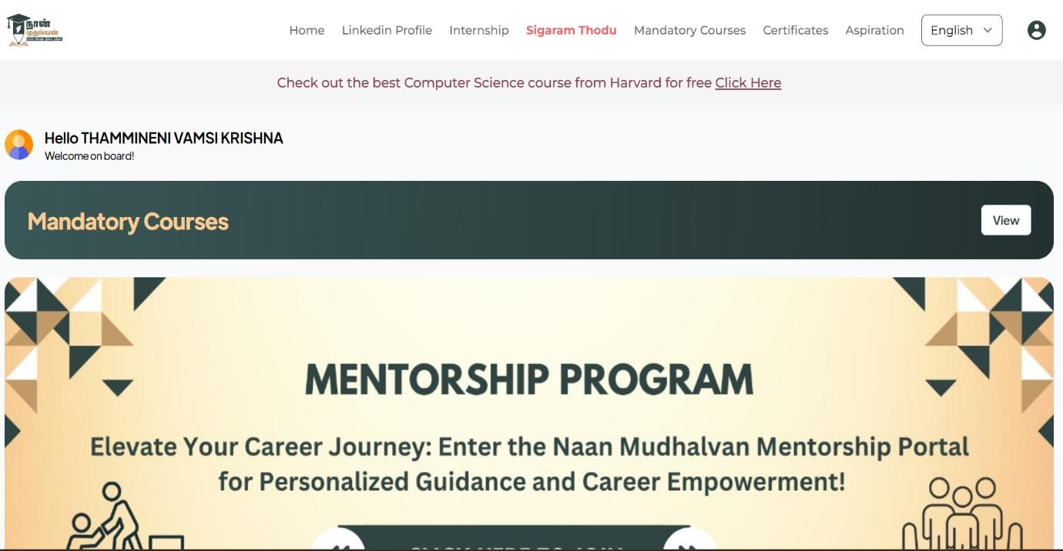

**Step sss**

**Step2 :**

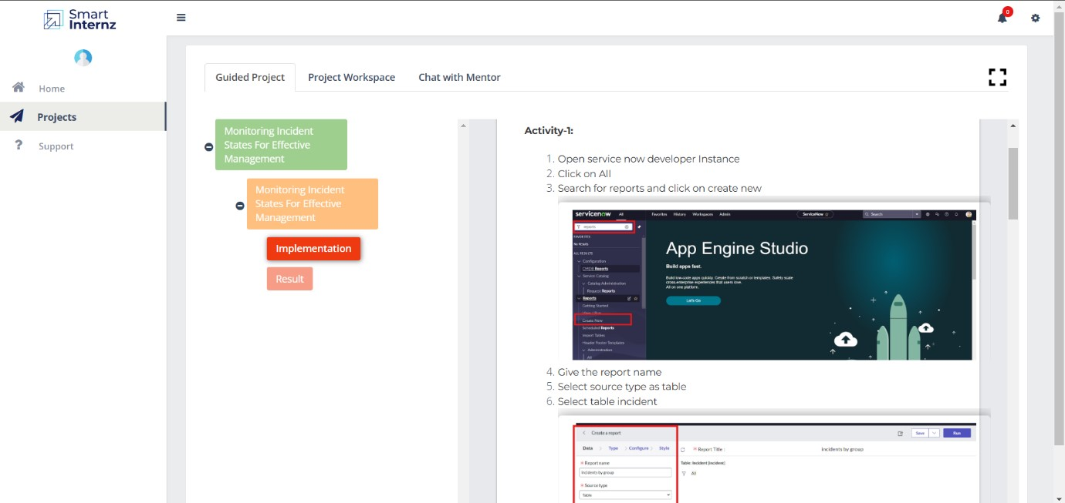

**Step3 :**

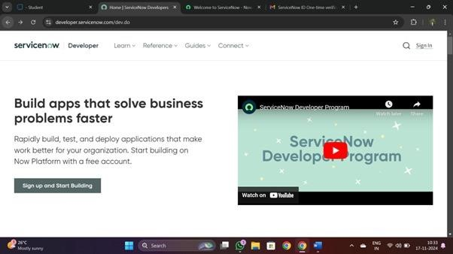

**Step4 :**

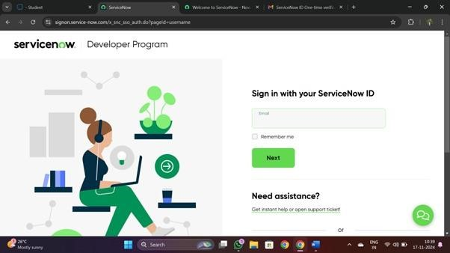

**Step 5:**

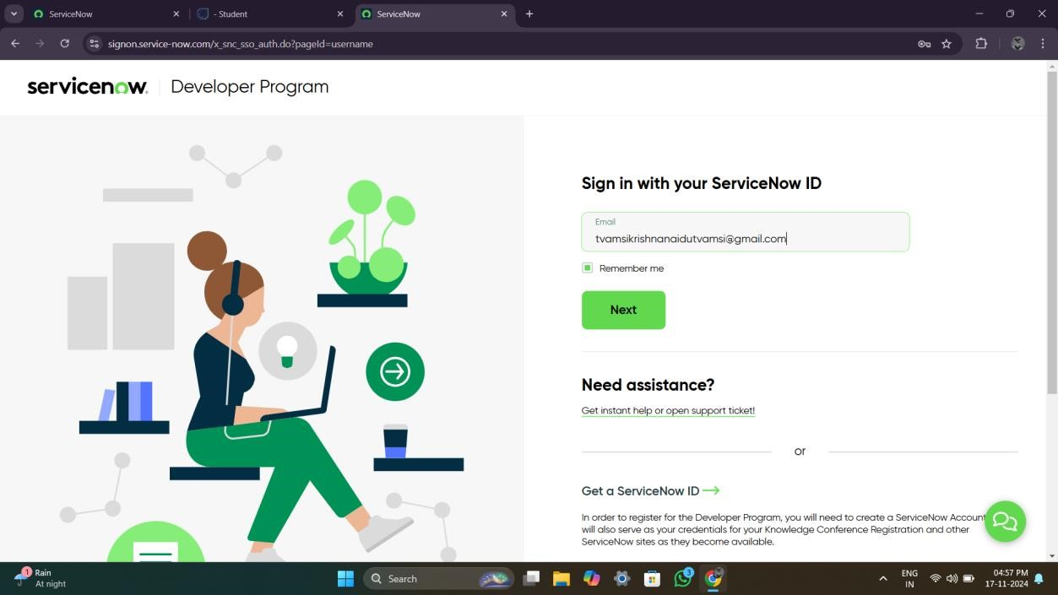

1. Open service now developer Instance
2. Click on All
3. Search for reports and click on create new

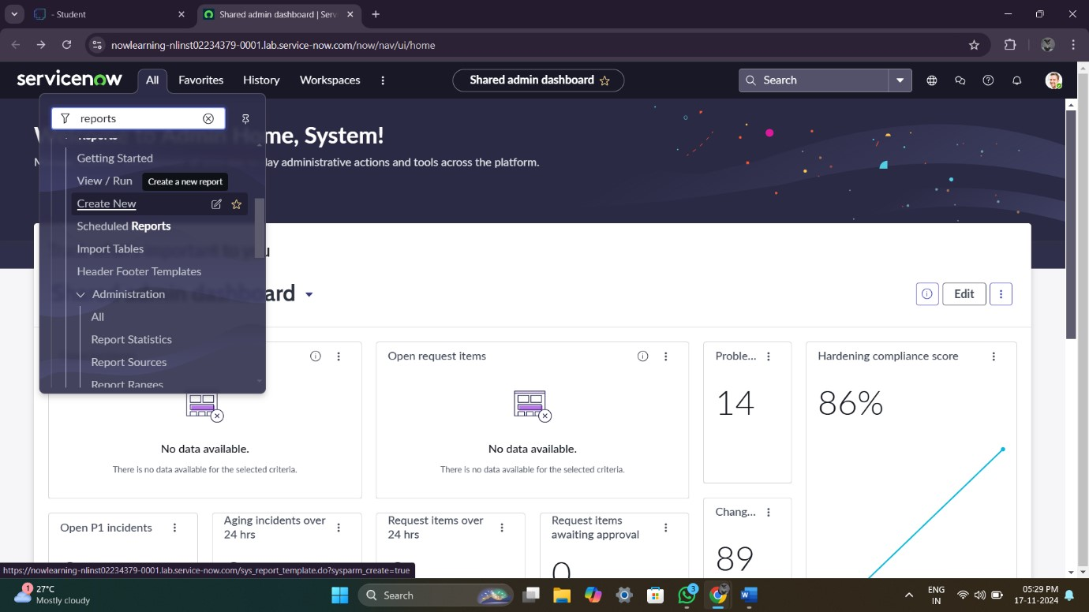

4.Give the report name

5.Select source type as table

6.Select table incident

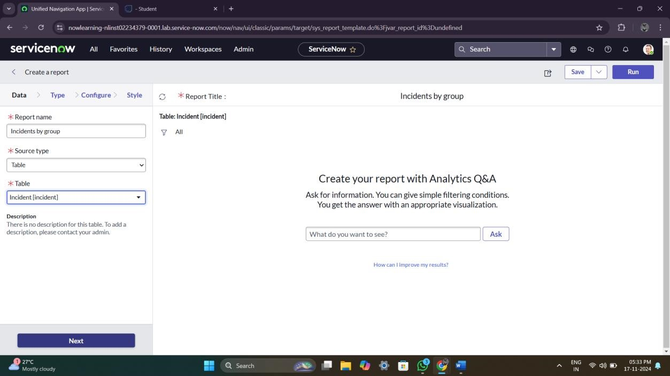

7.Click on next

8.Select type as pie chart

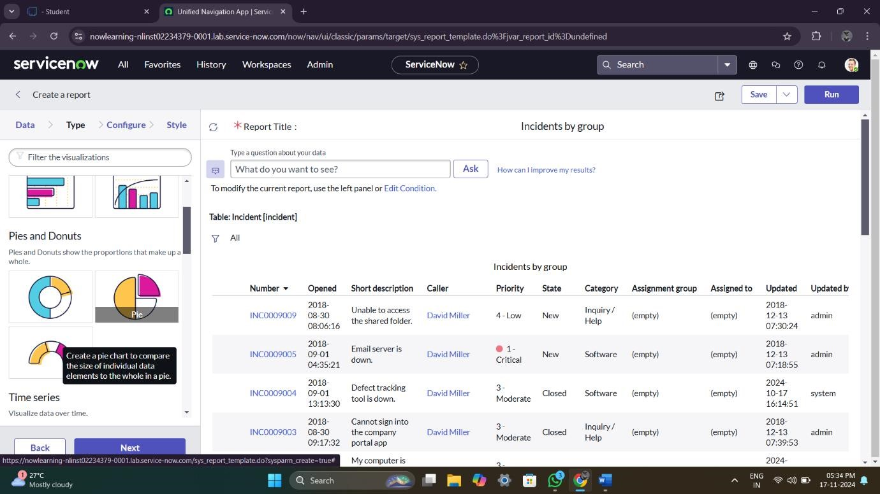

9.Click on funnel icon and give condition

Field : state

Operator : isoneof

Value : new,onhold,inprogress

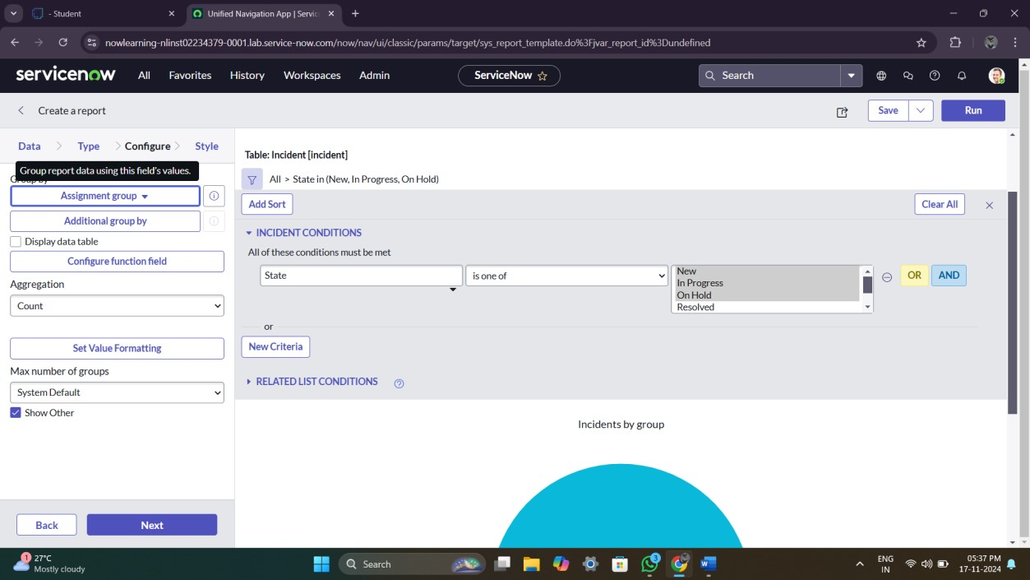

10.Click on next

11.Group by assignment group and click on next

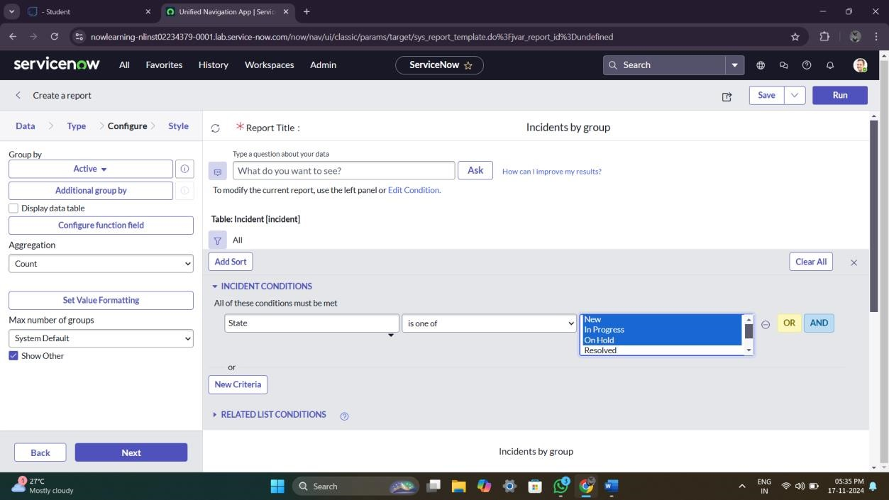

12.Click on save

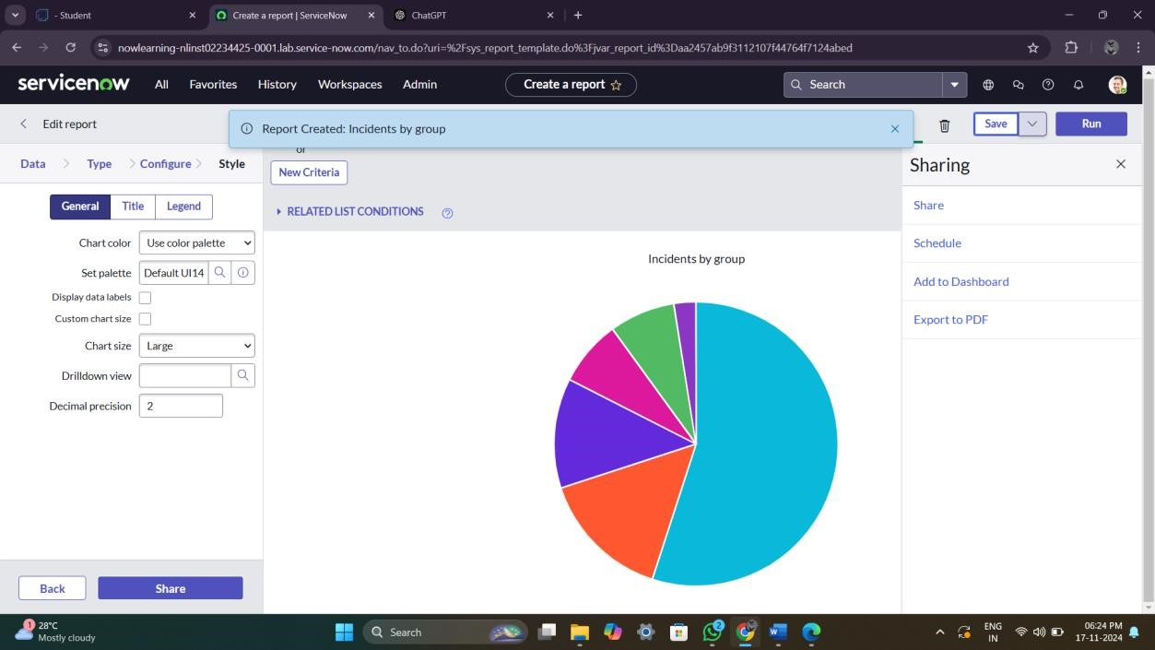

13.Click on run

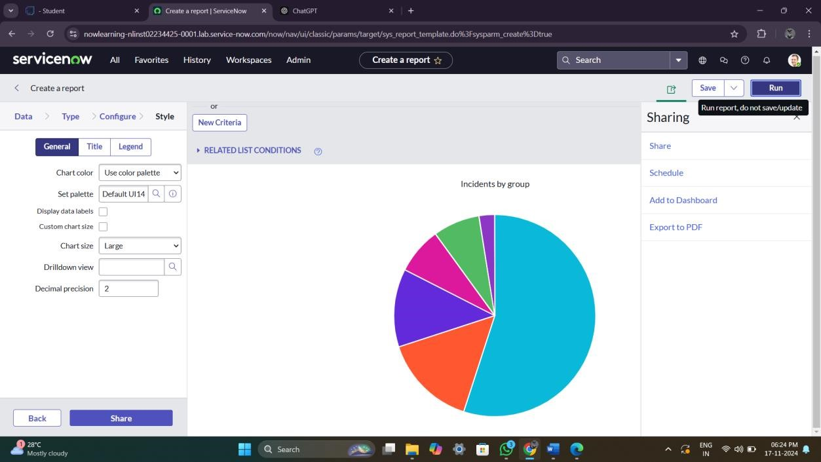

1. Now add report to dashboard

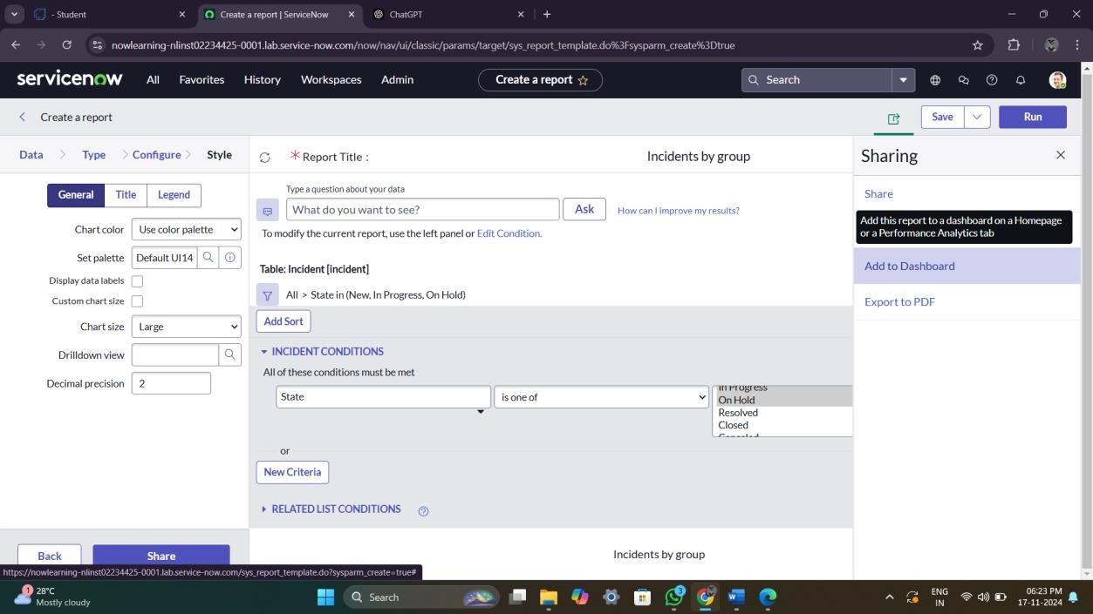

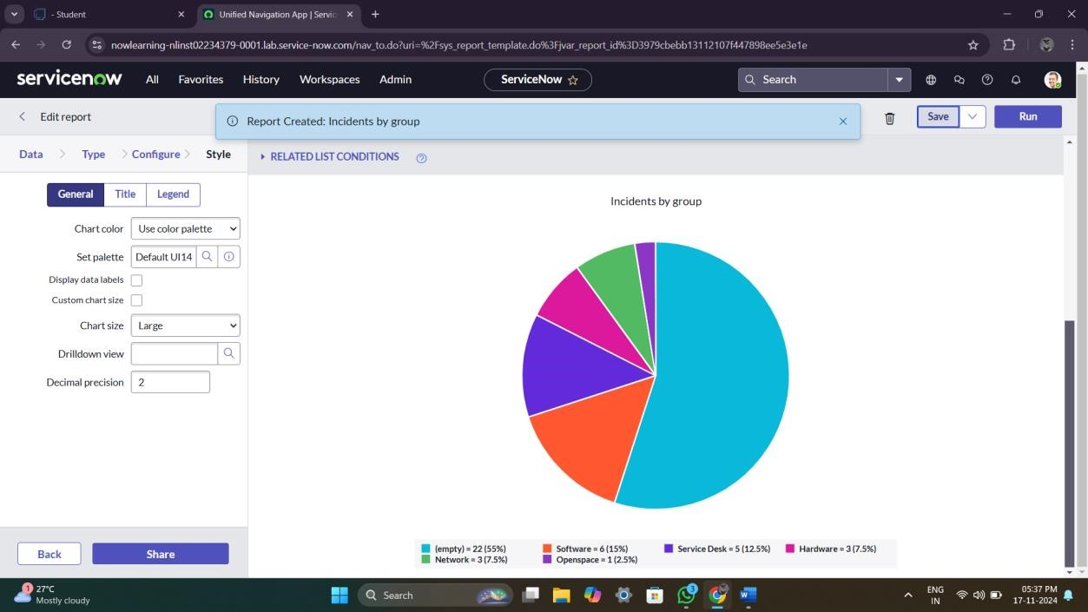

1. Give the dashboard and title name

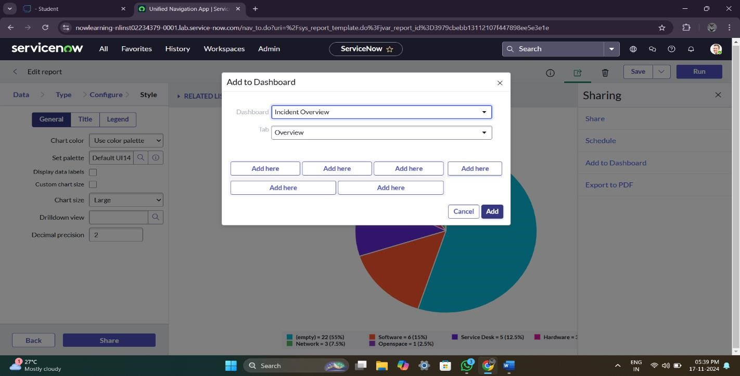

16.Click on add

17.New Dashboard was added to the incident overview folder

**Result**

1. Open service now PDI instance
2. Click on all
3. Search for dashboard
4. Select dashboard under self service

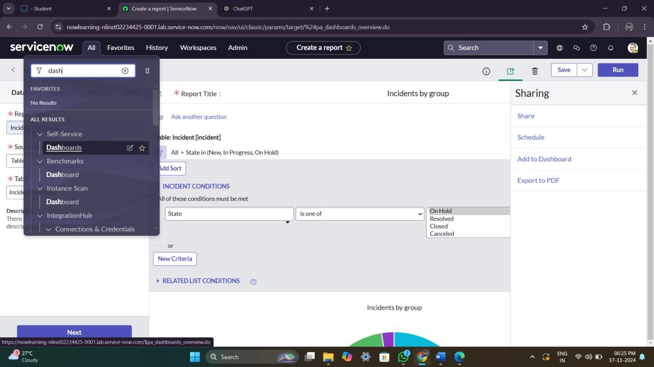

5.In the search bar enter incident

6.Select incident overview

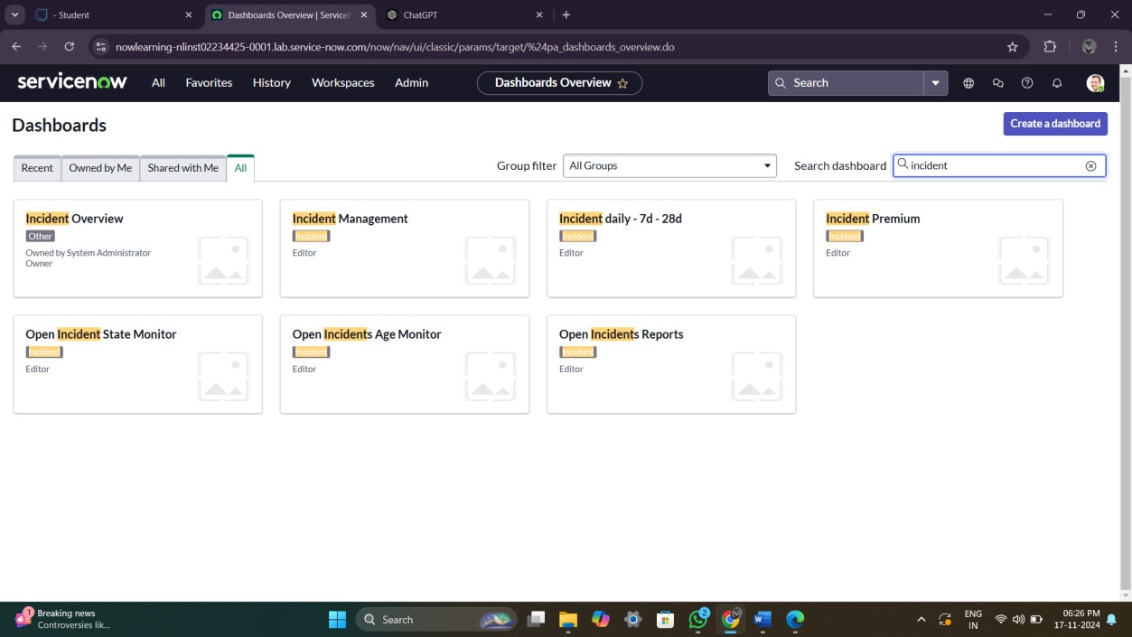

outputs

Member 1

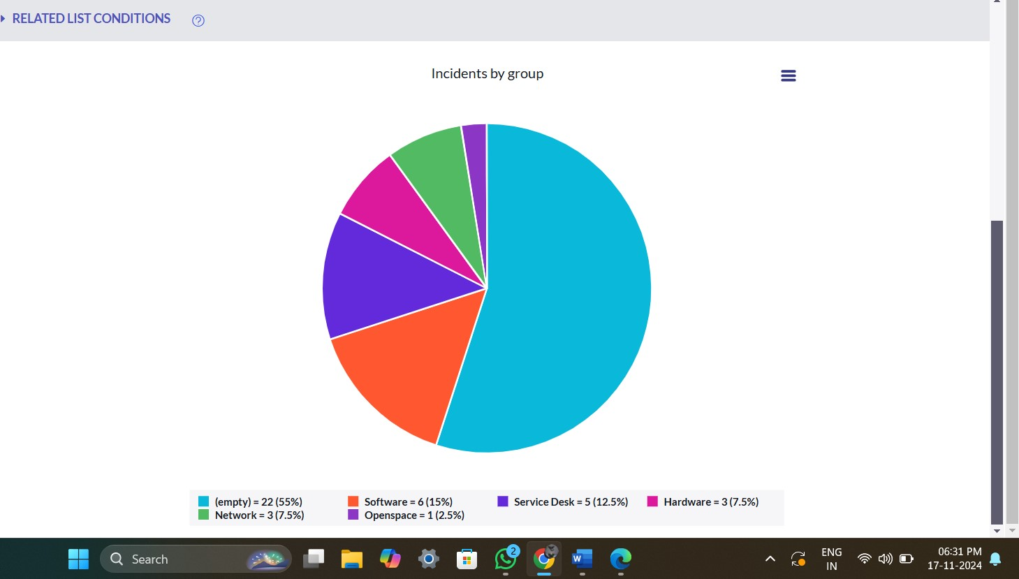

Member 2

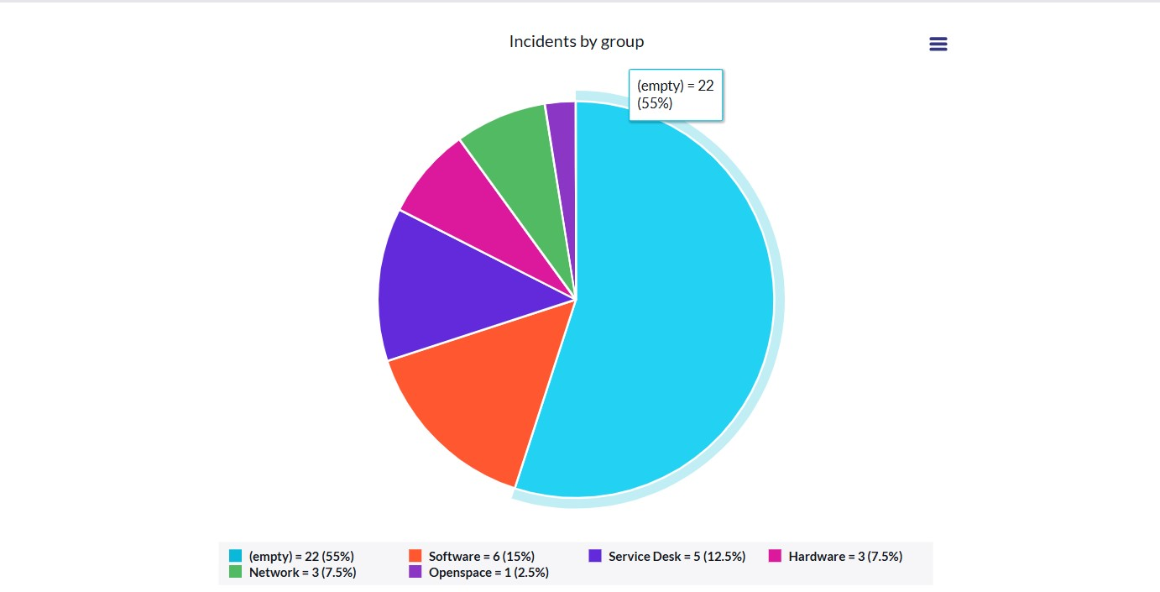

member 3

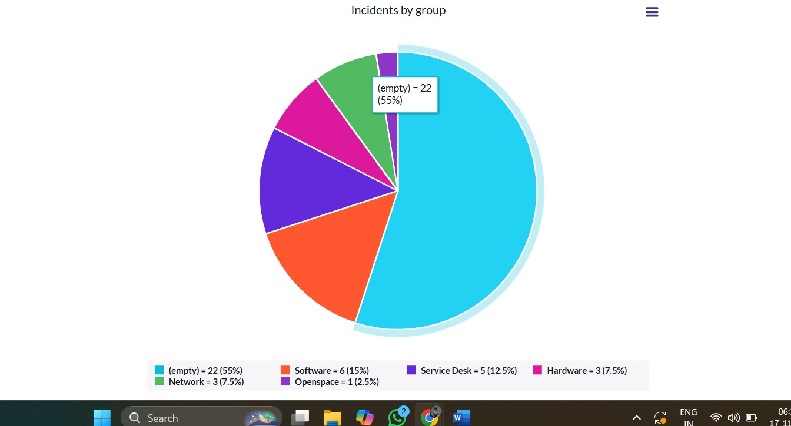

member 4

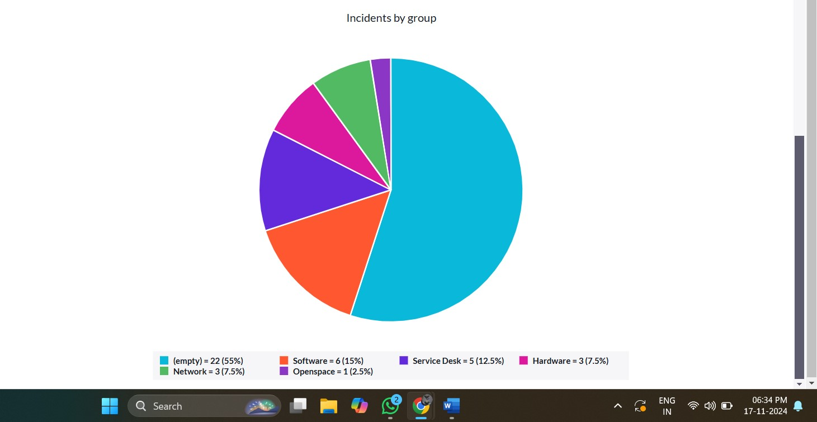

1. **Testing and Validation Unit Testing Objective:**

Validate individual components of the system to ensure they perform as intended and integrate seamlessly with the overall architecture.

**Approach:**

1. **Component-Level Testing:**
   * Test each module or component independently, such as incident tracking, notification triggers, and reporting features.
   * Verify input-output behavior for different scenarios and edge cases.
2. **Automation of Test Cases:**
   * Employ automated testing tools (e.g., Selenium, JUnit) to expedite repetitive testing tasks.
   * Develop scripts for regression testing to validate updates or changes without breaking existing functionality.
3. **Error Handling and Recovery Testing:**
   * Simulate erroneous inputs and system failures to evaluate how the system handles and recovers from unexpected conditions.
   * Confirm that error messages are clear, actionable, and do not expose sensitive data.
4. **Integration Testing:**
   * Test the interactions between integrated modules, such as the seamless flow of data from the incident creation module to the notification system. o Verify compatibility with third-party systems, including ITSM tools and communication platforms.

**User Interface (UI) Testing Objective:**

Ensure the user interface is intuitive, responsive, and provides a seamless user experience across all devices.

**Approach:**

1. **Functionality Testing:**
   * Validate that all UI elements (buttons, forms, dropdowns, etc.) perform their designated actions correctly.
   * Ensure workflows such as incident creation, status updates, and report generation function as expected.
2. **Usability Testing:**
   * Conduct usability testing sessions with end-users to gather feedback on interface design and navigation.
   * Assess whether users can complete key tasks efficiently and with minimal training.
3. **Compatibility Testing:**
   * Test the UI across various devices (desktop, tablet, mobile) and operating systems (Windows, macOS, Android, iOS).
   * Validate browser compatibility with popular options such as Chrome, Edge, Safari, and Firefox.
4. **Performance and Responsiveness Testing:**
   * Evaluate load times for dashboards, reports, and incident updates to ensure optimal performance.
   * Verify that the interface adjusts dynamically to different screen sizes and resolutions.

### 6. Key Scenarios Addressed by ServiceNow in the Implementation Project

ServiceNow is a powerful platform designed to streamline and automate workflows, making it an ideal tool for managing incidents efficiently. During the implementation of this project,

ServiceNow will address a variety of scenarios to enhance incident monitoring and resolution.

These scenarios span across key operational challenges and

**1. Incident Lifecycle Management**

**Scenario:**

An IT team needs to track incidents from initiation to resolution while ensuring timely updates and proper accountability.

**ServiceNow's Role:**

* Automates the incident lifecycle, including creation, categorization, prioritization, assignment, resolution, and closure.
* Tracks incident status in real-time, providing stakeholders with up-to-date information.
* Enforces workflows based on predefined business rules to ensure consistency.

**2. Automated Escalations and SLA Management Scenario:**

High-priority incidents require immediate escalation when SLA thresholds are at risk of being breached. **ServiceNow's Role:**

* Monitors SLAs in real time and triggers automatic escalations to relevant teams or managers.
* Sends alerts and reminders for impending SLA breaches, ensuring compliance.
* Provides tools to redefine SLA policies based on organizational requirements.

## 7. Conclusion

The *Monitoring Incident States for Effective Management* project has successfully achieved its objectives, delivering a robust and scalable solution for incident management. By leveraging advanced features and best practices, the project has transformed how incidents are tracked, resolved, and prevented, contributing significantly to operational efficiency and stakeholder satisfaction.

Through the implementation of an end-to-end incident lifecycle management framework, the project has streamlined the process of capturing, categorizing, prioritizing, and resolving incidents. Real-time monitoring capabilities ensure that stakeholders are consistently updated on incident statuses, fostering greater transparency and accountability across teams. Automated workflows have reduced manual effort, accelerating response times and enabling quicker resolution of critical issues.

The integration of advanced analytics tools has been another major accomplishment, empowering decision-makers with actionable insights. The system now provides detailed reports and visualizations that highlight incident trends, recurring issues, and root causes. This data-driven approach allows teams to proactively address potential risks, reducing the likelihood of recurring incidents and enhancing overall system reliability.